Custer County Library Board
Minutes
April 11, 2018 Custer County Library

The Custer County Library Board of Trustees met at 1:00 p.m. on Wednesday, April 11th in the Library Conference Room. Members in attendance were Pat Hoffman, Jim Laverick, Renee’ Starr, and Marcy Swanda, with Seyward Rittberger presiding and Doris Ann Mertz recording minutes.

AGENDA CHANGES/CORRECTIONS

MINUTES
- March 14th Board Minutes: Marcy moved to accept the minutes as presented. Pat seconded the motion.

TREASURER REPORT: Jim moved to acknowledge the treasurer’s report. Marcy seconded the motion.

- GENERAL CHECKING : $23,077.96 as of 3/30/18
- COUNTY SPREAD SHEET: Balance $155,904.46; Expended 22%

LIBRARIAN REPORT: Trustees received a hard-copy of the Librarian Report for April discussing the topics below and including the Library statistics for March. The Report is attached to and is part of this month’s Minutes. Items discussed during the meeting and not covered in the written report are included below.
- Foundation: Jim added information from the Open House planning committee comprised of Jim, Terry Reetz, and Mark Hogg. They plan to hold an Open House in the Pine Room on a weekday evening sometime between mid-June and mid-July. The Open House will provide exposure for the Foundation, promote the opportunity to purchase a leaf on the new donor tree by donating to the Foundation , and the opportunity to become a member of the Foundation. They have not yet decided on the details for food/refreshments, but noted that they planned to do something similar to the Open House hosted by the library a few years ago.
- Bluebird Box Workshop
- Hermosa Family Fun Event
- Long-Term Care Insurance Information Session
- Vacation Rental Information Session
- Book Chat
- Easter Story-time
- 1,000 Books Before Kindergarten: Doris Ann showed the trustees the bag and folder that participants receive when they sign up and noted that 19 have signed up at Custer and 3 at Hermosa since April 1st. Some of those who signed up are new members of the library.
- ACT Prep: Sessions were offered on March 27th and April 10th with no participants. A track meet was rescheduled on the 10th, and team members returned home too late in the evening.
- A Wrinkle in Time Teen Book Discussion: The library partnered with Custer High School to offer a teen book discussion and movie trip on A Wrinkle in Time. Doris Ann visited Mrs. Karims’ 5th and 6th period 7th Grade classes to lead the discussions on April 10th. There were 36 participants. The classes went to the movie in Hot Springs on April 11th. The theatre held a special showing and offered discounted tickets, the library purchased the tickets, and the school provided transportation. Over 50 students are expected to attend the movie showing. (Some of the students missed the book discussion due to a Family and Consumer Science program.)

UNFINISHED BUSINESS:
- Printer Updates
The library’s laser jet printer and printer/copier/scanner both failed since the last meeting. They had exceeded the normal lifespan of printing equipment, and the board had approved their replacement when necessary at their January 17th meeting. A new laser jet printer and port was purchased for $560.76 along with a new toner for approximately $200. A new laser jet colored printer/copier/scanner and replacement toners were also ordered. The cost of the copier was around $900. Unfortunately, the one delivered did not have the automatic duplexer as requested. The correct machine is now on order. This copier comes with full toners.
- Strategic Plan Review & Update
A draft of the strategic plan with updates/revisions was e-mailed to trustees prior to the meeting. Pat made a motion to approve the Revised Strategic Plan. Renee’ seconded the motion. The motion carried unanimously.
- Sam’s Club Membership Opportunity
Doris Ann explained that the library’s new Sam’s Club Plus membership allowed 16 separate cards. Staff, trustees and volunteers can have Plus memberships under the library’s account for $40 each. This membership allows a certain percentage of cash back to the library for purchases made under member cards, allows early entry into the store, and allows free shipping on Sam’s Club.com orders. Trustees may opt to join during the coming year.

NEW BUSINESS:
- Review of Juvenile Shelving Proposal
Doris Ann had researched several options for replacement shelving on the Juvenile side of the library from The Library Store. The results ranged from $15,392 to $17,609. The trustees had asked her to look into the cost of hiring a local craftsman to make similar shelves. She received a proposal from Tom McGinnis to build and install eleven wooden adjustable shelving units finished with one coat of medium oak stain and two coats of varnish for the cost of $10,000. (The materials would cost $7,000 and the labor would cost $3,000.) Tom would also install the ball transfer units (similar to casters) to be purchased by the library. These casters would cost approximately $1,000. A copy of the proposal is attached to these minutes. The trustees were pleased with the proposal, but had questions regarding the need to open the project to bids by others. Doris Ann said she would find out the County’s policy on when bids are required for projects and e-mail the results to them. If no bids are required, the board could take action by e-mail and proceed with the proposal.
- American Indian Programming Opportunities
Doris Ann updated the trustees on possible summer programming opportunities highlighting the American Indians of our region. She contacted Dr. Craig Howe of CAIRNS (Center for American Indian Research and Native Studies) to inquire about his availability and fees for a lecture. He said his cost was $500 plus travel expenses. She also contacted the new Owinza Quilting Cooperative formed outside Kyle on the Pine Ridge Reservation. She asked about the possibility of some of their members coming to Custer with their quilts to talk about the significance of the quilts in their culture and the goals of their quilting cooperative. They said they would love to hear from the library to talk about details once they got through their grand opening and things started settling down.

ANNOUNCEMENTS:
- AARP Tax Preparation on Mondays through April 16th
- Military Kids Story-time April 13th @ 10:00 a.m.
- Natural Cleaning Solution Essential Oil Make-n-Take – April 20th at 4 p.m.
- Book Chat –April 26th at 4:30 p.m.
- Black Hills Storytellers and French Creek Folk Event – May 11th @ 7 p.m.
- Rotary Club Presentation – May 21st at noon

ADJOURNMENT: The meeting was adjourned at 1:40 p.m.

NEXT MEETING: May 9th at 11:30 a.m. at the Hermosa Library

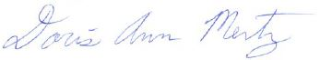
Doris Ann Mertz
Secretary/Treasurer
Librarian Report – April, 2018

Foundation Update: The Foundation held a meeting on March 22nd. They took a picture in front of the new donor tree to send to the newspaper. Ann drafted a letter, and everyone signed it to thank the maintenance department for their work in putting up the donor tree. A committee was formed to plan an Open House event. Discussion began about the development of a new five-year plan. Their next meeting is April 19th at 9:30 a.m.

Bluebird Box Workshop: The library hosted a Bluebird Box Workshop led by Custer State Park on March 14th at 4:30 p.m. There were 41 attendees. Julie Brazell led the workshop and provided an informational slide show. Shane of CSP made the kits and explained how to put them together. He and Jim Laverick helped the participants build the boxes. A few attendees did not realize that they needed to register for the class, so there were not enough kits. However, Julie told them to come out to the park office, and she would give them a kit. Participants really seemed to enjoy the workshop. Julie mentioned that she liked using our facilities to hold classes and said we should look for other opportunities to partner together to provide programs for the community.

Hermosa Family Fun Event: Seyward and Doris Ann hosted a library table at the Hermosa Family Fun Event on March 22nd. Bert provided library trivia questions and a correct answer allowed participants could enter their names into a drawing for a chance at 3 BAM gift cards. The event was well attended, and many people stopped by our table. We also handed out information about the 1,000 Books Before Kindergarten program. The March 28th edition of the Chronicle included a picture of Seyward asking trivia questions to some kids.

Long-Term Care Insurance (LTCI) Info Session: We contacted the SD Department of Social Services and asked them to hold an information session on LTCI at the request of a patron. Kathy Skoglund led the session on March 28th at 5:30 p.m. We had 11 participants, and the session was very informative. Several of the attendees thanked us for hosting the session and said they learned a lot.

Vacation Rental Information Session: The SD Department of Revenue contacted the library about holding a “taxpayer information” session on March 29th at 6:00 p.m. The session provided information on how to treat vacation rentals for tax purposes, obtaining a license, collecting sales tax, etc… The program had 11 participants.

Book Chat: The March Book Chat was held on the 29th at 4:30 p.m. and had 10 participants.

Easter Story-time: Our Easter Story-time and egg hunt were held on Friday, March 30th. We had 29 kids and 22 adults for a total of 51. That’s a higher percentage of adults than we normally see, but several kids brought both mom and dad or mom and grandma with them.

1,000 Books Before Kindergarten: This new program kicked off on April 1st. We have been promoting it in our programs/events, through the YMCA preschool, through the WIC office, on Facebook, in the Buffalo Bytes, and in the newspaper. Kate Najacht wrote a nice article on the program for the March 28th edition of the Chronicle. The included welcome letter gives you an idea of how the program is structured. The number of participants signed up since April 1st will be provided at the meeting.

ACT Prep: Oral Report
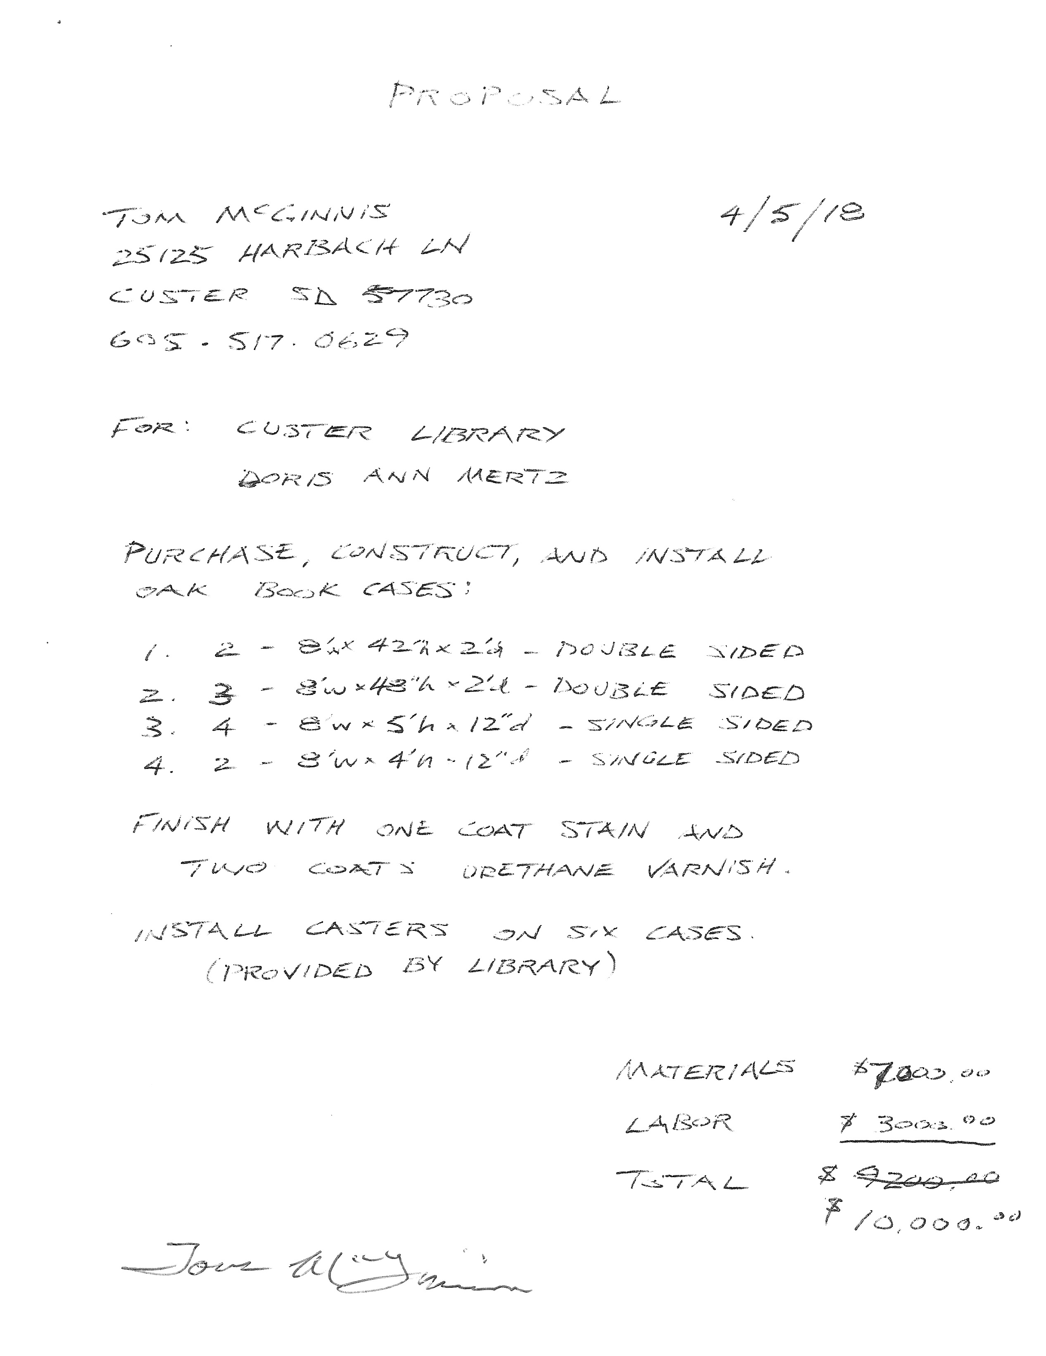
From: Renee [custerstarr@yahoo.com]
Sent: Friday, April 13, 2018 9:43 AM
To: Patricia Hoffman
Cc: Carol and James Laverick; Marcy Swanda; Doris Ann Mertz; Seyward Rittberger
Subject: Re: Juvenile Shelving

Aye!
Reneé Starr

From: Ken Swanda [kenmarcys@gmail.com]
Sent: Friday, April 13, 2018 8:38 AM
To: Carol and James Laverick
Cc: Seyward Rittberger; Patricia Hoffman; Doris Ann Mertz; Renee' Star
Subject: Re: Juvenile Shelving

Yea
Marcy
Sent from my iPad

On Apr 12, 2018, at 5:53 PM, Carol and James Laverick <buzz.murph@gmail.com> wrote:
Vote: Yea
On Apr 12, 2018, at 5:52 PM, Seyward Rittberger
<ksrittberger@yahoo.com> wrote:

I vote yes! Thank you for checking into this.
Seyward
On Thursday, April 12, 2018, 5:45:30 PM MDT, Patricia Hoffman <eandphoff@hotmail.com> wrote:

I vote aye for the motion! Thanks, Doris Ann, Marcy & Jim.
Pat

Sent from my Verizon, Samsung Galaxy smartphone

-------- Original message --------
From: Carol and James Laverick <buzz.murph@gmail.com>
Date: 4/12/18 5:33 PM (GMT-07:00)
To: Marcy Swanda <kenmarcys@gmail.com>
Cc: Doris Ann Mertz <cuslib@gwtc.net>, Patricia Hoffman <eandphoff@hotmail.com>, Renee' Star <custerstarr@yahoo.com>, Seyward Rittberger <ksrittberger@yahoo.com>
Subject: Re: Juvenile Shelving

2nd
On Apr 12, 2018, at 5:30 PM, Ken Swanda
<kenmarcys@gmail.com> wrote:

I make a motion to proceed with the juvenile shelving project utilizing the local bid.

Sent from my iPad

On Apr 12, 2018, at 3:07 PM, Doris Ann Mertz
<cuslib@gwtc.net> wrote:
Good news! Our States Attorney, Tracy Kelley, said that we do not have to seek bids for projects under $25,000. So, if someone would like to write up a motion and send it to everyone, we could take action via e-mail to proceed with the juvenile shelving replacement. If everyone could do a “reply all” in their responses, it will be easy for me to print off the votes for documentation purposes. Then, I will attach the documentation to the minutes of the April meeting
(which I haven’t written yet), and we will consider them for approval at the May meeting.

FYI, this is what our Bylaws say about taking action in this manner:
“Any action which is required to be taken, or which may be taken, at a meeting of the library board of trustees, may be taken by fax, mail, telephone, or email. Such consent shall have the same force and effect as a vote in person at a regular board of trustees meeting. The written responses to the action will be attached to the minutes of the immediately preceding meeting.“

Also, right after the meeting, I received an e-mail from Mile-Up Marketing with a link to the new website for my review. It’s not live yet or anything, but I get to see how it is going to look and operate. It’s pretty exciting! I am working on providing some content for the page. When we get some more of the content fleshed out, I’ll send you the link, so you can explore it. I hope you will like it!

Doris Ann Mertz
Custer County Library Director
447 Crook St., Suite #4
Custer, SD 57730
605-673-4803
cuslib@gwtc.net

